**Last Name: Suh First Name: Joowon Student ID: 44414081**

1. [10 pts] Find the text of all tweets that were posted by the tweeter with the handle ‘patgotweet’.

a) [7 pts] SQL Query:

b) [3 pts] Result: (1 Row)

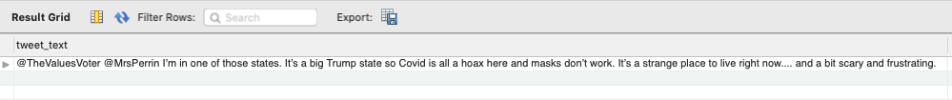

2. [10 pts] List the **distinct** domains of expertise for checkers who have verified tweets that have the hashtag “*COVID19*”. (**Note: The hashtag value is all in capital letters.)**

a) [7 pts] SQL Query:

b) [3 pts] Result: (2 Rows)

3. [10 pts] List the handles of Tweeters who have posted a tweet that has been verified by a Checker who started as a checker after the date “2020-01-31 03:41:49”.

a) [7 pts] SQL Query:

b) [3 pts] Result: (5 Rows)

4. [15 pts] For verified tweets that contain the hashtag "COVID19", find the associated evidence URLs, verification comments, and checkers' first and last names **(Again: “COVID19” is in all caps.)**

a) [12 pts] SQL Query:



b) [3 pts] Result (12 rows):

5. [15 pts] Find the user IDs, first names, and last names of checkers that have **all** the domains of expertise from the user with ID = 68. (Note: Your answer will include the “ID = 68” checker as well, of course.)

a) [12 pts] SQL Query:

b) [3 pts] Result: (3 Rows)

6. [10 pts] List the phone numbers of checkers who have verified the tweet with the id “1321211561046933514” ***and*** who are experts in “Infectious Diseases” (Note the use of the word “and” instead of “or” from the previous assignment!)

a) [7 pts] SQL Query:



b) [3 pts] Result: (2 Rows)

7. [15 pts] Find tweet ids and the number of replies for each tweet that has one or more replies. List only the top five tweets that have the highest number of replies.

a) [12 pts] SQL Query:

b) [3 pts] Result: (5 Rows)

8. [15 pts] For tweets that have two or more reactions (replies and/or quotes), print their tweet id along with their number of replies and number of quotes. (Note that for such tweets, the sum of replies and quotes should be 2 or more). Order the result by the number of reactions in largest-first order.

a) [12 pts] SQL Query:

b) [3 pts] Result (9 rows):

